**INSTALLING HADOOP AND HOW HDFS ARCHITECTURE (NameNode and DataNode) WORKS.**

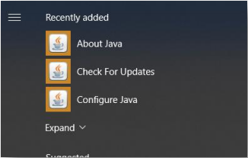First Install Java

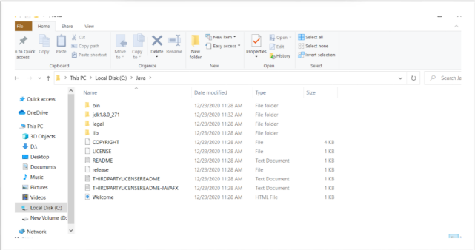

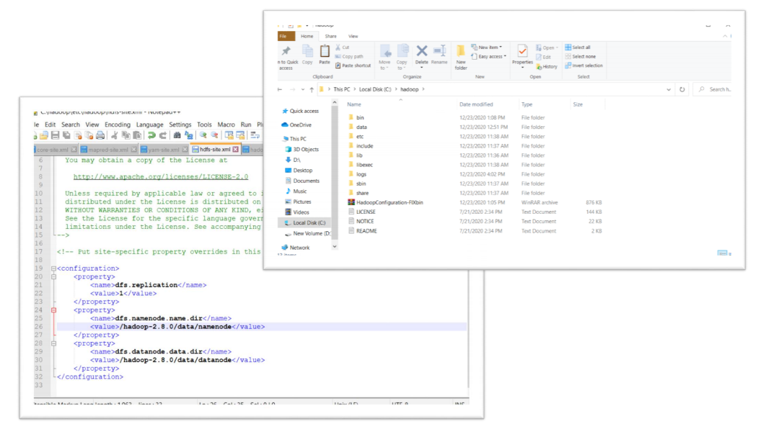**And then Install Hadoop (Configuring codes in some of Hadoop XML files: core,mapred,yarn,hdfs,Hadoop env. Codes source from Web) and I created Name Node and Data Node in data Folder and in HDFS XML**

**CMD CONFIGURE**

Checking the Java if it’s already installed (Checking the Java Version)

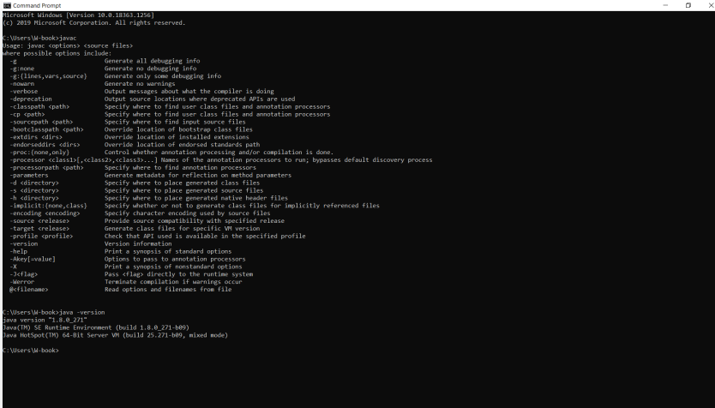

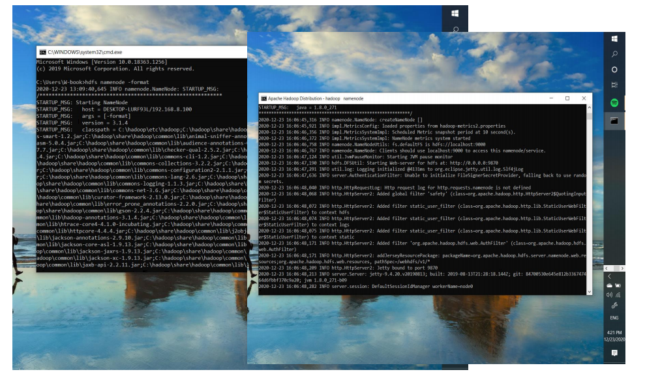**Configuring and Creating Namenode (by typing “hdfs name node -format”)**

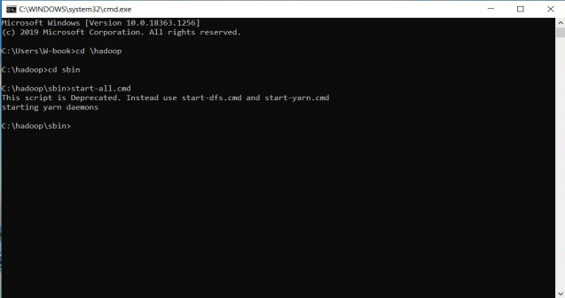**After creating Name Node starting all cmd in Hadoop sbin by typing “start-all.cmd**”

**To show and start the Data Node**

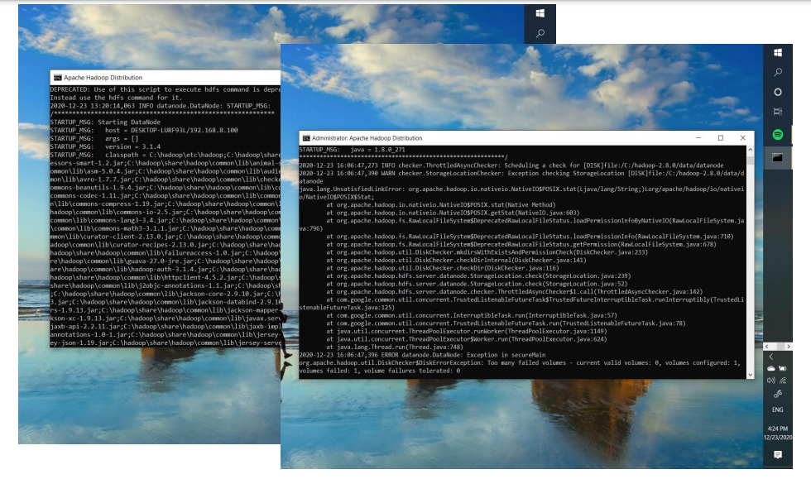

**Resource Manager**

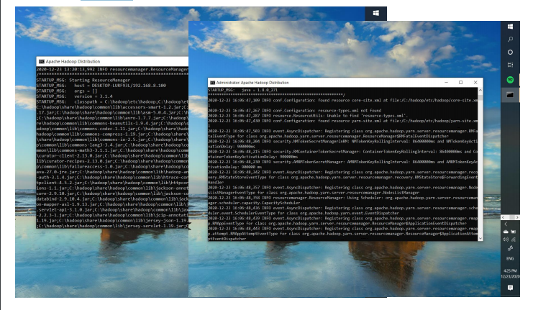

**And Node Manager**

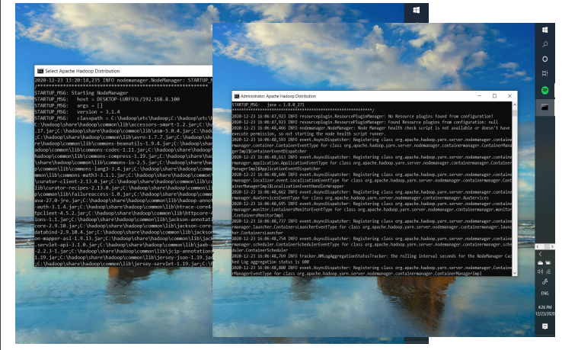

**Checking the localhost if the Hadoop has already installed by typing “http://localhost:9870/” but first don’t close all the CMD running (NameNode, DataNode, ResourceManager,NodeManager) so that the localhost link is working**

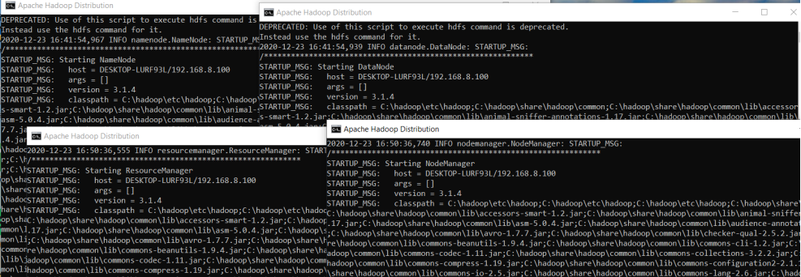

**After accessing the localhost link in the web browser you will see this**

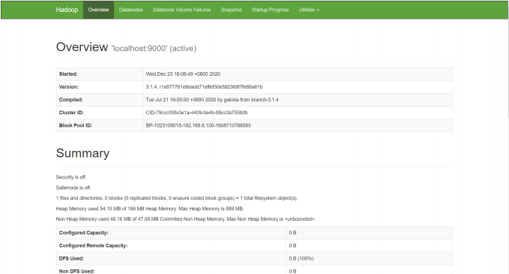

**SUCCESSFULLY HADOOP HAS BEEN INSTALLED and Name Node and Data Node HAS BEEN CREATED**

